Physics 20 Lesson 9H Rotational Kinematics

In Lessons 1 to 9 we learned about linear motion kinematics and the relationships between displacement, velocity, acceleration and time. In this lesson we will learn about rotational kinematics. The main difference between the two types of motion is while linear kinematics deals with linear displacements (), rotational kinematics deals with angular displacements (θ).

Rotational Motion and Angular Displacement
When a rigid body rotates through a circular path, it must do so around a center known as its axis of rotation. As the rigid body rotates it sweeps out an angle about the fixed axis. This angle is known as the angular displacement. Angular displacement is the angle (θ) swept out by a line passing through any point on the rotating object and intersecting the axis of rotation perpendicularly. Angular displacement is positive (+) if it is counterclockwise and negative (-) if it is clockwise.
P
s
r
Reference Line
θ
O

In rotational motion all points of the rigid body move in circles about some axis of rotation, O. Referring to the diagram above, the point P moving counter clockwise around the circle, has an angular displacement of θ, relative to the positive x-axis. Note that the linear displacement that the point has moved through is an arc (s) of the circle.

Angles are commonly measured in degrees, but the mathematics of circular motion is much simpler if we use the radian for angular measure. One radian (rad) is the angle swept out by an arc whose length is equal to the radius. In our circle, point P is a distance r from the axis of rotation. If it has moved a distance s along the arc of the circle and s = r, then θ = 1 rad. In general,

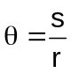 (1)

Another way to understand radians is to relate them to our previous knowledge about degrees. Radians and degrees are both angular units. In previous work you learned that there are 360º in a circle. For radians, the angle is related to the circumference of a circle
C = 2πr
In radians, there are 2π radians in a circle. In other words
2π rad = 360º

1 rad = 57.3º

Example 1
A wheel rotates through 270º, what is the rotation in radians?

Set up a ratio
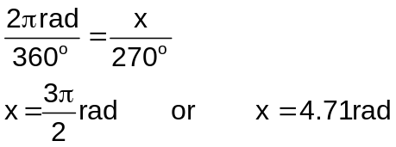

Example 2
2 synchronous satellites are put into an orbit whose radius is 4.23 x 10⁷ m. The orbit is in the plane of the equator, and the two adjacent satellites have an angular separation of θ = 2.00°. Find the arc length that separates the satellites.

** Once the angle (θ) is converted into radians, the relation s = θ r can be used.

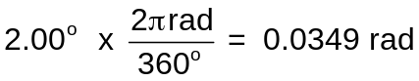

∴ s = θ r = (0.0349 rad)(4.23 x 10⁷ m) = 1.48 x 10⁶ m

Angular Velocity
To describe rotational motion, we also make use of angular quantities such as angular velocity (ω pronounced omega) and angular acceleration (α pronounced alpha).

Angular velocity is defined in a similar way with linear velocity, but instead of distance traveled we use the angular distance θ. Thus, the average angular speed, ω, is defined as
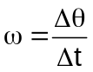 (2)

Angular speed is the angle through which the body has rotated in time t and its units are rad/s.

To find out how angular speed is related to linear, in this case tangential, speed, consider an object already undergoing uniform circular motion. The object maintains a constant speed as it revolves around a circle of radius (r) in a period of time (t). Clearly, if the total distance traveled around the circle is its circumference, 2πr, and the time for one complete rotation is t, then the constant average speed is

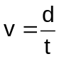
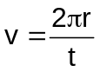 (3)
and the angular speed is given by

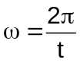 (4)

Substituting equation (4) into equation (3) we get:

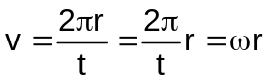

 (5)

Equation (5) draws our attention to an important idea. Consider two people standing on a moving merry-go-round; one person near the center and one near the outer edge of the merry-go-round. Both people experience the same angular speed ω since they both sweep out equal angles in equal time intervals, but the person on the outer edge has a greater tangential speed, since he is sweeping out a larger arc length in the same amount of time.

Example 3
A gymnast on a highbar swings through two revolutions in a time of 1.9 s. Find the average angular velocity of the gymnast in rad/s.

Δθ = 2.00 rev x (2π radians / revolution) = 12.6 radians

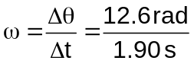 = 6.63 rad / s

Angular Acceleration
Angular acceleration, similar to linear acceleration, is defined as the change in angular velocity divided by the time required to make this change. The angular acceleration, α, is
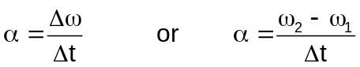 (6)
The unit is rad/s².

Example 4
A jet waiting to take off rev's his engine. As the engine idles, the fan blades rotate with an angular velocity of +110 rad/s. As the plane takes off, the angular velocity of the blades reaches +330 rad/s in a time of 14 s. Find the angular acceleration of the blades.
using equation (5)
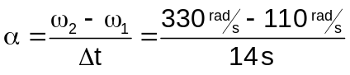 = 16 rad/s²

Rotational Kinematics
Our understanding of rotational velocity and acceleration takes into the realm of rotational kinematics. Using our previous kinematics equations we are able to derive equations explaining rotational motion. The mathematical forms of the linear and rotational kinematics equations are identical with the exception of the replacement of the linear variables with rotational variables.

Quantity Rotational Motion Linear Motion

Displacement θ d
Initial velocity ω_{i} v_{i}
Final velocity ω_{f} v_{f}
Acceleration α a
Time t t

Rotational Motion Linear Motion
(α = constant) (a = constant)

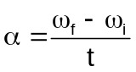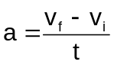
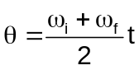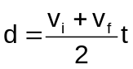
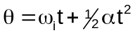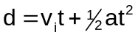
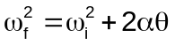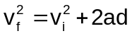

Example 5
The blades of an electric blender are whirling with an angular velocity of +375 rad/s while the “puree” button is depressed. When the “blend” button is pressed, the blades accelerate and reach a greater angular velocity in +44.0 rad (seven revolutions). The angular acceleration has a constant value of +1740 rad/s². Find the final angular velocity of the blades.

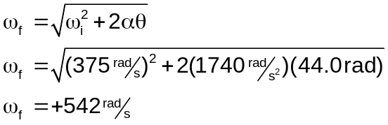

Hand-in Assignment
1. A bicycle odometer (which measures distance traveled) is attached near the wheel hub and is designed for 70 cm wheels. What happens if you use it on a bicycle with 60 cm wheels?

2. What are the following angles in radians: (a) 30º, (b) 90º, and (c) 420º ? (0.524, 1.57, 7.33)

3. A laser beam is directed at the moon, 380,000 km from earth. The beam diverges at an angle of 1.8 x 10⁻⁵ rad. How large a spot will it make on the moon? (6.8 km)

4. A bicycle with 68-cm-diameter tires travels 2.0 km. How many revolutions do the wheels make? (936)

5. A 20-cm-diameter grinding wheel rotates at 2000 rpm.
a. Calculate its angular velocity in rad/s. (2.1 x 10² rad/s)
b. What is the linear speed of a point on the edge of the grinding wheel?
(41.9 m/s)

6. A 70-cm-diameter wheel rotating at 1200 rpm is brought to rest in 15 s. Calculate its angular acceleration. (-8.4 rad/s²)

7. A 33-rpm phonograph record reaches its rated speed 2.8 s after turning it on. What was the angular acceleration? (+1.2 rad/s²)

8. Calculate the angular velocity of the earth (a) in its orbit around the sun, and (b) about its axis. (1.99 x 10⁻⁷ rad/s, 7.27 x 10⁻⁵ rad/s)

9. What is the linear speed of a point (a) on the equator, (b) at a latitude of 50º N, due to the earth's rotation? (463 m/s, 298 m/s)

10. An automobile engine slows down from 4500 rpm to 1000 rpm in 6.5 s. Calculate (a) its angular acceleration, (b) its angular displacement, and (c) the total number of revolutions the engine makes in this time. (-56 rad/s², 1872 rad, 3.0 x 10² rev)

11. A centrifuge accelerates at +120 rad/s² from rest to 10,000 rpm. What was the angular displacement? (4.6 x 10³ rad)

12. A phonograph turntable reaches its rated speed of 33 rpm after making 1.5 revolutions. What was the angular acceleration? (0.63 rad/s²)

13. A 40-cm-diameter wheel accelerates uniformly from 80 rpm to 300 rpm in 3.6 s. How far will a point on the edge of the wheel have traveled in this time? (14.3 m)

